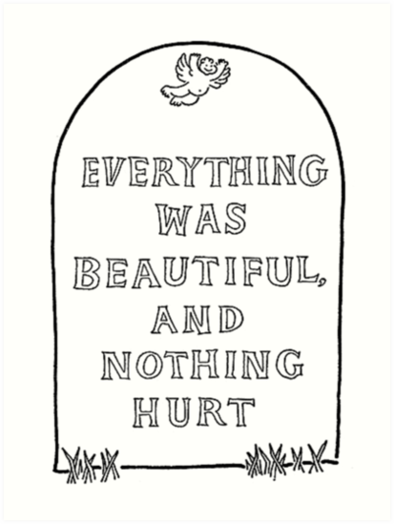

Final Words: Slaughterhouse Five Epitaph Assignment

At one point in the novel, Valencia asks Billy Pilgrim about the war. “Was it awful?” she asks. Billy responds, “'Sometimes. A crazy thought now occurred to Billy. The truth of it startled him. It would make a good epitaph for Billy Pilgrim—and for me too” (155). That epitaph is, of course, “Everything was beautiful and nothing hurt.

Of course, Slaughterhouse Five is a novel of irony and absurdity, featuring a hero who is distinctly unheroic, a survivor who is apathetic about his life, an eye doctor who is blind to reality, an optimist who can see his own doom. It is a novel about war from a distinctly anti-war perspective. It is a novel with a grave subject written by a satirist and humorist.

Given all these contradictions, we can safely assume that the epitaph Billy and Vonnegut have chosen for themselves is likewise ironic. If you read with awareness, you understand that while the epitaph speaks to Billy’s fantasy about the world and his experience, it says nothing about the reality of either.

So let’s reimagine these last words with a sense of that reality.

Assignment:
- Create an epitaph for Billy Pilgrim that truly reflects Vonnegut’s message of war, life and death.
- Draw a tombstone (or use attached drawing) and write your epitaph there. Please decorate with appropriate images.
- Then, in a reflection of THREE paragraphs, explain your epitaph. Argue why this epitaph is more appropriate than the original. Use evidence. Do not merely summarize plot. Show me ya read.
- Follow protocols for formal academic writing.
- Upload to Google Classroom by 8 PM Wednesday night.
Extra Credit (a possible 10 extra credit points)
- Make an epitaph of your high school experience.
- Draw a tombstone (or use attached drawing) and write your epitaph there. Please decorate with appropriate images.
- Then, in a reflection of TWO paragraphs, explain your epitaph. Tell me why this final send-off best expresses your time at El Segundo High School.
- Have some fun/make it appropriate.
- Note: points not guaranteed. Make the effort worthy.
- Upload to Google Classroom by 8 PM Wednesday night.

