Unit 5

Transcendentalism and Anti-Transcendentalism

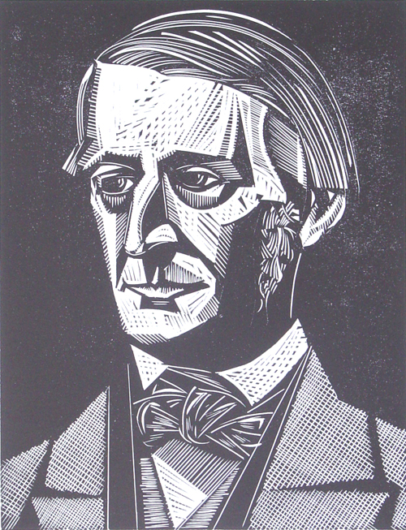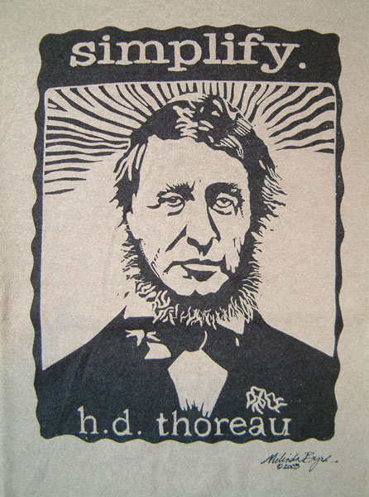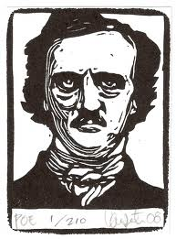

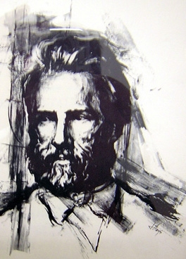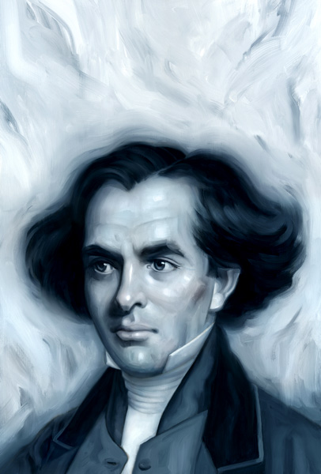
HOMEWORK PACKET SCORING RUBRIC

POINT  RANGE | PERFORMANCE DECSCRIPTION | SCORE
25 - 23 | Student’s responses to questions are clear, effective, and demonstrate a thorough critical understanding of the text in developing insightful answers. Answers are coherently organized, with ideas supported by apt reasons and well-chosen examples. Student’s work is original, thoughtful, and complete. The work is generally free from errors in grammar, usage, and mechanics; writing style is effective and fluent, marked by syntactic variety and a clear command of language.
22 - 20 | Student’s responses to questions are clear and demonstrate a critical understanding of the text in developing insightful answers. Answers are well organized, with ideas supported by apt reasons and well-chosen examples. Student’s work is thoughtful and complete. The work may have a few errors in grammar, usage, and mechanics; writing style is effective, marked by some variety and facility in the use of language.
19 - 17 | Student’s responses generally address the topic, but may slight some aspects of the task; responses demonstrate a generally accurate understanding of the text in developing plausible answers. Answers are adequately organized, with ideas generally supported by reasons and examples. Student’s work is thoughtful and complete. The work may have a few errors in grammar, usage, and mechanics; writing style is effective, marked by some variety and facility in the use of language.
16 - 0 | Responses are comprised largely of superficial analysis, tending to discuss the obvious, showing a lack of imagination or insight. Answers generally lack coherence and often fail to use sufficient or accurate evidence or reasoning to prove an argument. The work in general is lackluster, sloppy, carelessly composed, and obviously was denied the serious and scholarly attention it was expected to receive.
**Any homework packet that is incomplete cannot receive a score higher than 15 points.

Ralph Waldo Emerson
From Nature
“I Become a Transparent Eyeball” (pg. 225)

Vocabulary
Exhilaration

Slough

Decorum

Blithe

Egotism

- Provide the dramatic situation for this poem.

- What accounts for the shift in the author’s perspective?

- What is the thematic significance of an eyeball? Why is the eyeball transparent?

- What does elemental nature reveal about human nature?

- Name at lease THREE tenets of Transcendentalism at work in this poem. Explain each and cite a line.

- Describe the concept of Oversoul as it appears within this work.

.

Ralph Waldo Emerson
“Self Reliance” (pg 226-228)

Vocabulary

Capitulate

Deprecate

Dilapidate

Interlope

Philanthropy

- In “A Nonconformist,” against what institutions of society did Emerson rebel? What were his reasons for refusing to conform?

- When, according to Emerson, was charity legitimate? When was it illegitimate?

- Emerson disapproved of traveling to “get away from the self.” When did he approve of it?

- What did Emerson mean by “the indifference of places” (227)?

- What or whom is “the giant” Emerson referred to in Traveling?

- According to Emerson, what did a man lose when his interests lie solely in acquiring property? What did he mean by “living property”? Provide a specific example of “living property.”

Ralph Waldo Emerson
Man Thinking
From “The American Scholar” (pg. 229)

Vocabulary
Delegate

Metamorphose

- In your own words, summarize the fable in the first part of the work.

- According to Emerson how did members of society judge one another when they first met? Is this a fair way to assess strangers? Why or why not?

- What is the difference between a “mere thinker” and “a man thinking”?

- Who was the audience for this speech? Why was Emerson’s appeal particularly appropriate for this audience?

- According to Emerson, what is a true scholar? (Hint: revisit the fable at the beginning of the work).

- What do you believe was Emerson’s message to his audience?

Henry David Thoreau
Why I Went Into the Woods/Why I Left the Woods
From Walden (pg. 232-239)

Vocabulary
Disreputable

Evitable

Incapacitate

Obsequious

Pertinacity

- What did Thoreau mean when he said that a person may “live what was not life”?

- Specifically, how did Thoreau suggest an individual simplify his life? Would this advice have any appeal in modern America? Why or why not?

- What seemed to fascinate Thoreau in “The Battle of the Ants”? Provide specific examples.

- In the first selection Thoreau explains why he went into the woods; why then did he leave?

- State three specific reasons from the work that show Thoreau embraced Transcendentalism (note: speak in the language of the tenets)

Henry David Thoreau
“Civil Disobedience” (pg. 240-243)

Vocabulary
Alacrity

Conciliate

Eradicate

Inherent

Penitent

- What was Thoreau’s attitude toward government? How did it compare to Emerson’s vision as outlined in A Nonconformist?

- Why did he believe that “majority rule” was not always the most moral rule?

- What did Thoreau mean by a “majority of one”? What term did Emerson use that was comparable?

- Why did Thoreau choose jail over taxes? Why did he feel free in jail?

- In Thoreau’s estimation, what was the most moral type of government? What political party would he most likely align with today?

Herman Melville
“What Redburn Saw in Launcelott’s-Hey” (pg. 274)

Vocabulary
Vault

Accosted

Howard

Meager

Smolder

Squalor

- Provide three examples of powerful, evocative diction from the second paragraph of the story. What type of mood does this create?

- In what city is the story set? Why is this setting representative the time period?

- What is the rhetorical significance of having a young, inexperienced boy, a stranger in a strange land, narrate the work?

- Name three tenets of Anti-Transcendentalism at work in the story. Explain each and provided cited evidence to substantiate your claim.

- Since Anti-Transcendentalism is a reaction to or the antithesis of Transcendentalism, what Romantic ideals are discredited in this work?

Nathaniel Hawthorne
“The Minister’s Black Veil” (pg. 253-261)

Vocabulary
Consort:

Pathos

Sagacious

Torpor

Visage

- How does the black veil affect the minister’s parishioners? How does it affect the minister’s sermons?

- What does Hawthorne mean when he writes, "For the Earth, too, had on her Black Veil (cite)? How is this statement darkly romantic?

- Consider the dead maiden and the young bride, how might they appear alike. What thematic statement might these foils suggest?

- Explain how the minister feels about the veil. What happens to his personal life after he puts on the veil.

- What one desirable effect does the veil have?

- What does the veil symbolize? Cite a line from the text to substantiate your claim.

- On his deathbed, why does Father Hooper see “on every visage a black veil”?

Edgar Allan Poe
“Annabel Lee” (pg. 212)

Vocabulary
Covet:

Dissever:

Kinsmen:

Sepulcher:

- Provide the dramatic situation for this poem.

- Name three tenets of the Gothic at work in the poem. Explain each.

- Explain tone in this work. What diction or lines support your claims?

- Poetic Terms:
  - Write out one example of a rhyming couplet.
  - Write out two examples of assonance.
  - Write out two examples of alliteration.
  - Write out two examples of internal rhyme.
- How does the rhythm of the poem affect mood?

- What is your mood at the end of the work

Edgar Allan Poe
“The Cask of Amontillado” (pg. 199)

Vocabulary

- What is grotesque about this work?

- What is arabesque about this work?

- Identify elements in the story that are humorous? What does the humor add to the story?

- Describe the narrator's attitude toward himself and his actions? How might the narrator appear to manipulate the truth?

- Do any of Fortunato's words and actions support the narrator's belief that Fortunato is worthy of hatred?

- How does the setting of "The Cask of Amontillado" change as the story progresses?

Edgar Allan Poe
“Hop Frog” (pg. 206)

Vocabulary
Corpulent

Masquerade

Eclat

Flambeau

Flax

Scruple

- Do you feel the king's fate is justified? Why or why not?

- Explain the rhetorical significance of the wine; how does it serve a Gothic element. How does it serve a thematic element in the work?

- Detail Hop Frog's appearance. How might his physical form mirror his interior landscape?

- "The Cask of Amontillado" is told from a first person point of view, mainly to show Montressor's twisted mind as he delves deeper and deeper into revenge. Why do you believe "Hop Frog" is told from the third person objective point of view?

- Poe makes extensive use of animal imagery throughout the story. Name at least three instances of this. How might this reference a larger thematic meaning?

- What is Gothic about this story? What is grotesque? What is arabesque?

- In both organization and tone, the story has a fairy-tale like quality. How does this add to the overall mood of the piece?

Frederick Douglass
“What the Black Man Wants” (pp. 278-280)

Vocabulary
Aristocracy

Chastise

Deprive

Enfranchise

Stigma

- What was the purpose of Douglass’ speech? Who was his audience?

- Why did Douglass believe that benevolent societies were more kind than just toward the Negro? How had that hurt the Black man’s cause?

- How does Douglass answer the question: “What shall we do with the Negro?” What does he mean by this response?

Abraham Lincoln
“The Gettysburg Address” (p. 281)

Vocabulary

Conceive:

Consecrate:

- Why did Lincoln make the speech at Gettysburg?

- What did Lincoln say was the importance of the “honored dead”?

- How did he use the speech as a vehicle to reinforce his goal of reunifying the nation?

- Who did Lincoln vilify in this speech. Explain the reason for this choice.

Chief Seattle
“This Sacred Soil” (pp. 282-284)

Vocabulary
Proposition

Reproach

Sachem

- What did Chief Seattle believe is the Indian relationship to God?

- Did Chief Seattle blame the White Man for what happened to his people? Explain.

- What differences did he point out exist between the nature of the White Man and the nature of the Indian?

- What did Chief Seattle mean when he said, “the White Man will never be alone”?

